CO₂ Emission Prediction for Climate Change Mitigation.
Abstract.
Carbon (IV) oxide has contributed majorly to Air pollution. Air pollution has led to many chronic diseases. The sources of these CO₂ emission are: combustion of fossils fuels this contribute great percentage others are from transportation and electricity/heat sector etc. These factors have led to government and world health organization come up with mitigation to control and monitor the emission of carbon dioxide and other pollutants.
Government like China was the most affect with air pollution this was due to having a lot of industries. They came up with a program to cleanse the air. This has prompted different organizations and government to come up with a strategy to monitor the amount of CO2 emission. One of the strategies is introducing EVs so that it can lower the amount of carbon dioxide emissions.
The ability to accurately monitor carbon emissions is a critical step in the fight against climate change. Precise carbon readings allow researchers and governments to understand the sources and patterns of carbon mass output. While Europe and North America have extensive systems in place to monitor carbon emissions on the ground there are few available in Africa.
Chapter 1

1.1 Background study.

1.2 Problem statement.
The escalating threat of climate change due to rising global greenhouse gas, primarily in the form of CO₂, necessitates the development of a robust machine learning model capable of predicting and addressing these emissions.

1.3 Main objective.
To assist in understanding, monitoring and ultimately reduce greenhouse gas emissions.

1.3.1 Objectives.
- To identify high impact CO₂ sources.
- To validate policy evaluation.
- To identify early warning of increase in the levels of CO2.

1.4 Scope.
The project scope encompasses data collection, preprocessing, feature engineering, model selection, training, validation and deployment of the ML model. Additionally, the project will actively engage in education, advocacy and ethical considerations to ensure responsible and effective use of the model for climate change mitigation.

A few similar works have been done on time series data using machine learning, deep learning, and statistical model. Let us know about a few of them. The work by Masini et al. (2021) surveys the most recent advances in supervised machine learning (ML) and high dimensional models by considering linear and non-linear methods for time-series forecasting and combining ensemble and hybrid models ingredients from different alternatives. They also apply time series forecasting in the economic and financial fields. In Crespo Cuaresma et al. (2004), the author studied the forecasting abilities of a battery of univariate models, including AutoRegressive (AR) models.
In Elsworth and Güttel (2020), the author proposed an RNN model with a dimension reducing symbolic representation to deal with the sensitivity of hyperparameters in any time series model and solved the limitation of other models in the initialization of random weights. Also, their model is faster without affecting the performance of forecasting. Also, Zuo et al. (2020) collected the CO₂ emission data from the different provinces of China and proposed a model named LSTM-STRIPAT, an integrated model to predict emissions in 2020, and in Amarpuri et al. (2019), the research is aimed at predicting the CO₂ levels in the year 2020 to make the Government of India understand the challenges. A deep learning hybrid model of Convolution Neural Network and Long Short-Term Memory Network (CNN-LSTM) is used as a forecasting model.
A prediction-based work was done by Kumar et al. (2020), in which they have collected the data from Delhi and National Capital Region (NCR), India, to predict the Air quality index. They have applied the machine learning models and measured the performances in terms of MAE, MSE, RMSE, and MAPE metrics. Similar work by Kumar et al. (2020) measured the PM_{2.5} pollutant particles in the Delhi atmosphere. In this work, Extra-Trees regression and AdaBoost-based regression models are applied to predict PM_{2.5} concentrations effectively. They have also considered additional atmospheric and surface factors such as wind speed, atmospheric temperature, and pressure.
The work (Ahmed et al. 2010) applied eight machine learning models to famous M3 time series competition data and compared them. The models’ multilayer perceptron and the Gaussian process regression performed the best. In Nyoni and Bonga (2019), authors used the Box-Jenkins ARIMA approach on time series data of CO₂ emission in India from 1960 to 2017, and based on the forecast, they suggested five policy prescriptions to improve the environmental conditions.
ARIMA model has also been used to analyse air pollutants and to predict them based on historical data (Gopu et al. 2021). And it is also said that this is an efficient way by which we can find out the values of the pollutants when exceeding the limits prescribed by the World Health Organization (WHO). SARIMA is an ARIMA capable of dealing with the seasonality of the dataset, and SARIMAX is SARIMA with X factor, which is nothing but exogenous factors that affect the data. The work (Nontapa et al. 2020) analysed and forecasted time-series using the SARIMA and SARIMAX model with decomposition method and compared them on evaluation metric MAPE where SARIMAX with decomposition model outperforms traditional ones. There is information regarding time series forecasting and limitation with the SARIMAX model in the paper (Özmen 2021) with the application of retail store data. In this work on CO₂ emission, a random forest regressor has been used for forecasting. In the paper (Fang et al. 2020) author proposed an optimal random forest model for the accurate prediction of an infectious diarrhea epidemic, considering meteorological factors. He compared his proposed model to ARIMA and ARIMAX, and the RF model outperforms with MAPE of approximately 20% to the ARIMA model, with MAPE reaching 30%.
In the paper (Lepore et al. 2017), the author describes that with the introduction of the EU’s new CO₂ emissions regulation, ships’ operators are required to implement systems that will monitor and report their CO₂ emissions. These systems will help them make informed decisions regarding their operations. Due to the complexity of the navigation information that ships provide, there is no widely available standard method or solution that can be used in real environments. This paper extensively analyzes the various regression techniques that can exploit ships’ navigation information. The study is made based on the data collected by the Grimaldi Group’s Ro-Pax cruise ship during its operation. It aims to identify possible methods and models that can be used to analyze the ship’s CO₂ emissions and develop a predictive model.
There is a project which aims to develop models and artificial neural networks to predict the energy consumption of office buildings in Chile and CO₂ emissions (Pino-Mejías et al. 2017). Eight fundamental variables have been used to analyze the design parameters of commercial air-cooled cooling and heating systems. The results show that the linear regression model with higher accuracy and better performance are those with the least value of predictive errors. It is expected that the models will help to estimate the energy savings that different design concepts would produce during the construction phases. This procedure was developed to generate training data for ANN using a statistical method. The resulting database contains case files that are representative of the office buildings. The statistical models that rely on the multi-perceptron method are more accurate than those that rely on the standard linear regression model. They can reproduce the results of ISO 17000:2008 with high accuracy. This study aimed to develop an ANN model to predict office buildings’ energy consumption and greenhouse gas emissions in Santiago, Chile. The framework proposed in this study can be used to develop energy-efficient building standards that are realistic and sustainable.
A paper (Wang et al. 2020) shows that the data on carbon emissions are accurate for developing effective carbon mitigation strategies. For China, the US, and India, the data pattern on their carbon emission are different. The US carbon emission data shows volatile growth and decline. In this paper, the author proposes a method to improve the accuracy of the data by developing a combination of the ARIMA and the Metabolic Nonlinear Grey Model (MNGM). This method could reduce the residual error of the model MNGM by applying ARIMA and BPNN. It can also decrease the forecasting error of the model. As for the US’ carbon emissions are expected to keep a downward trend during the next couple of decades.
In Mele and Magazzino (2020), the author studies the monthly data of iron and steel industries, air pollution, and economic growth for China from 2000 to 2017 to find the relationship between them. The approach used for this work is the long short-term memory (LSTM) model. As per the paper, the iron and steel industries are the most energy-consuming and air-polluting sectors, which became the primary concern of the Chinese government. For energy supply, the iron and steel industry depend on coal, which produces a high percentage of direct CO₂ emissions. In this work, authors did not choose standard econometric techniques, rather they have used the machine learning method; LSTM comes under a recurrent neural network to analyze the relationships. And lastly, they successfully showed the strong relationship between the Iron and steel industries, and CO₂ emissions, which may help the government to make managerial policy implications.
In Magazzino et al. (2021), the author’s interest is to examine the link between ICT, economic growth, urbanization, environmental pollution, and energy consumption using the ML models. In this work, time series, panel data of 25 OECD countries from 1990 to 2017 has been used. The author used the D2C algorithm, which predicts the linkage between two variables in a multivariate setting by (i) constructing a set of relationship features based on asymmetric descriptors of the multivariate dependency and (ii) learning a mapping between the features and the presence of a causal link using a classifier. The same algorithm is used in work (Mele and Magazzino 2021) over the annual data from yeras1980 to 2018 to analyse the relationship between pollution emission, economic growth, and COVID-19. For COVID-19, data was collected from 29th January 2020 to 18th May 2020.
In Bakay and Ağbulut (2021), SVM, ANN, and deep learning models have been used for forecasting five gases that are CO₂, CH₄, N₂O, F-gases, and total GHG. This work has used Turkey’s energy production data from 1990 to 2014. Findings indicate that deep learning-based models perform better with RMSE, rRMSE, MBE, and MAPE performance metrics.
In MK (2020), the author has worked on the role of energy use in the prediction of CO₂ emission and economic growth in India using artificial neural networks. The author uses two optimizers as Adam and Stochastic Gradient Descent for prediction, and it is found that Adam optimizer works as a better optimizer for their work. There are some other suggested models too for forecasting (Hewamalage et al. 2021) author talked about the recurrent neural network model for competition data. In this work, they have also presented a detailed discussion on the current status of the RNN model and its future directions.
In 1978, a statistical model named Holt-Winters (Chatfield 1978) was introduced, which deals with trends and seasonal variation. According to this paper, some available idiosyncratic modifications can improve the Holt-Winter’s forecasts. There is an argument that Box-Jenkins and a non-automatic version of Holt-Winters would be a fairer comparison. There is a suggested method for predicting and estimating trends in specific datasets. If multiple trends in data and the forecasting model dimensions increase, this trend estimation becomes a more tedious task, so the paper (Sbrana 2021) has a closed-form result for simple prediction and estimation of the multivariate smooth-trend model, a state-space representation of Holt-Winters celebrated recursions.
In Magazzino (2017), author investigated the relation among the CO₂ emission, economic growth, and energy used in the South Caucasus area and Turkey using three variable Vector Autoregressive (VAR) technique over the panel data. The empirical analysis uses yearly data of real per capita GDP, per capita CO₂ emissions, and per capita energy uses in 1992–2013 for Armenia, Azerbaijan, Georgia, and Turkey. Analysis shows the reaction of CO₂ emissions to energy use is negative and statistically significant in both the estimated coefficients and impulse responses.
Later in Magazzino et al. (2020), authors investigate the casual relationship among solar and wind energy production, coal consumption, economic growth, and CO₂ emissions for three most significant contributors of CO₂ emission and energy consumers i.e. China, India, and the USA. They have used an advanced methodology in machine learning to verify the predictive causal linkages among variables. The Casual Direction from Dependency (D2C) algorithm set CO₂ emissions as the target variables.
The authors (Magazzino et al. 2021) investigated the casual relation between renewable energy technologies, biomass energy consumption, per capita GDP, and CO₂ emissions for Germany. In this work, they devised an innovative model, the Quantum model, combined with machine learning models to find the relation. As a result, they find biomass energy uses powerful for the reduction of CO₂ emission and use of renewable energy more potent for the CO₂ reduction.
After exploring the literature, we have observed that several methods, including various algorithms, theories, and mathematical models, have been studied to track trends, and forecast different harmful gases such as CO₂, CH₄ etc., with energy consumption, the death rate in COVID-19. Furthermore, we have observed that statistical, machine learning and deep learning models are not applied together. To fill this gap, we have applied all the three classes of models for effective prediction of CO₂ emission, which tells about the best-performing models and analyses the reasons behind their performance.

The dataset
We have used CO₂ and greenhouse gas emission data^{Footnote1} of 40 years in this work. We have collected the data from the year 1980 to 2019 by using the CAIT data source, which is the most comprehensive and includes all the sectors along with gases. Greenhouse gas emission data indicates that 60% of the GHG emissions are from the top 10 emitting countries. In this work, we have used the univariate time series data of India, having an increasing CO₂ emission trend.
The data pre-processing is done before splitting the data into training and testing samples. Test data is used to evaluate the performance of the models, and better performing models are used for forecasting the CO₂ emissions.
The descriptive analysis of the dataset CO₂ emission data is shown below in Table 1. After observing the min, median, and max values, we can see the increasing behaviour of CO₂ emission.
Table 1. Descriptive analysis
Full size table
The dataset used in the work has an increasing trend as shown in Fig. 1. From Fig. 1, we can observe that trend indicates the increasing or decreasing behaviour of the data w.r.t. time. Furthermore, seasonality is analysed to observe the dataset’s characteristics in terms of regular and predictable changes that recur every calendar year. Any predictable fluctuation or pattern that recurs or repeats over a one-year period is said to be seasonal.
Fig. 1
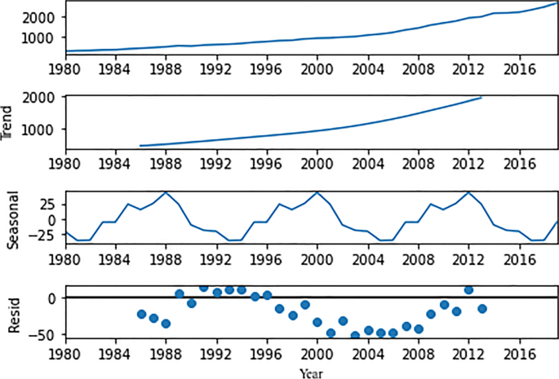
Time series properties of variable
Full size image
We have also analysed the residual behaviour of the dataset, and removed which were left over observing the trends and seasonality of the data. In time-series models, we assume that data is stationary and only the residual components satisfy the stationarity condition.
Stationarity behaviour of the data is tested using augmented Dickey-Fuller (ADF) (Ajewole et al. 2020) test and Kwiatkowski-Phillips-Schmidt-Shin (KPSS) (Baum 2018) and converted into stationary data by applying the shifting and differencing approaches.

Proposed model
As we have discussed in section 1, CO₂ emission in India is growing significantly faster and is quite dangerous for the environment and ultimately to all living beings, so the reduction of CO₂ emission should be the highest priority for the government and industries. An accurate forecast of emissions would directly help in policy-making and implementing them, so for this purpose, we have a CO₂ emission time series data with some attributes for the last 40 years, from 1980 to 2019. The requirement for this work was a univariate dataset, so it needed some data pre-processing and data cleaning to deal with not available values in the dataset. The dataset contains two columns, one for years and the second for CO₂ emission in metric tons.
We have used a few time series-based models to forecast India’s 10-year CO₂ emission. The dataset has an increasing trend and is also stationary. For this particular kind of dataset, we have used three statistical models: ARIMA, SARIMAX, and Holt-Winters model, two machine learning models, i.e., linear regression model and random forest regression model, and in last a deep learning model LSTM (S. Kumar et al. 2021). Before applying the models to the dataset, we have split it into two parts i.e. training data and testing data to train and test the models.
Different models have different ways of dealing and working with the data. Here, we have discussed these six time-series models briefly:

Autoregressive-integrated moving average
We start with a basic stationary model like AR and MA in time series analysis. But to handle non-stationary models, we go with utoregressive-integrated moving average (ARIMA). MA, AR, and ARMA are specific cases of the ARIMA model.
A model that uses the dependency between an observation and a residual error from a moving average model applies to lagged observations. ARIMA is an acronym that stands for autoregressive-integrated moving average. Specifically, AR (autoregression), which is a model that uses the dependent relationship between an observation and some number of lagged observations, I (integrated) is the use of differencing of raw observations to make the time series stationary and MA (moving average).
A standard notation is used for ARIMA (p, d, q), where the parameters are substituted with integer values to indicate the specific ARIMA model being used quickly. Where p is the number of lag observations included in the model, also called the lag order, d is the number of times that the raw observations are differenced, also called the degree of differencing, and q is the size of the moving average window, also called the order of moving average. In work, we have applied ARIMA (1, 2, 1) to predict the CO₂ emissions (Wellington 2019).

Seasonal autoregressive-integrated moving average with an exogenous variable (SARIMAX)
Before knowing about SARIMAX, we will try to understand SARIMA. SARIMA is seasonal autoregressive-integrated moving average in which, along with the trend, there is seasonality as well. This is ARIMA, but having the effect of seasonality is something with those time series that have both trends and seasonality. Now, we have to understand the X factor of SARIMAX, which is an exogenous variable that means some external factor is impacting it. It is said that there are some factors outside the overall factor we are studying (Özmen 2021).

Holt-Winters model
The Holt-Winters model is a traditional model dealing with time-series data behavior. These behaviors mean the average value, the increasing or decreasing trend, and the seasonality, which is nothing but the repetitive pattern in a cycle. Based on the seasonal component of data, this model has two variations. The first is the additive Holt-Winters model, and the second is the multiplicative Holt-Winters. In this work, the multiplicative model has been used to forecast the next 10 years’ data. The multiplicative Holt-Winters is described as a method that calculates the value of the level, trend, and seasonal adjustment that are exponentially smooth. Since this method is best suited for data with increasing trends and seasonality, this paper considers this model for CO₂ emission forecasting (Chatfield 1978).

Linear regression
Linear regression is a machine learning model to solve regression problems. This model solves the problem by assuming a linear relationship between the given input attributes and the output, as shown in Eq. (1).
Target output=Input1×weight1+Input2×weight2……………Inputn×weightn+BiasTarget output=Input1×weight1+Input2×weight2……………Inputn×weightn+Bias
(1)
Here n is a total number of attribute/input features. Weights are also called regression coefficients learned while training the model based on train data. The bias is nothing but the intercept as linear regression is based on the linear equation. Time series forecasting is also a regression problem where inputs are previous data. In this work, CO₂ emission data is univariate data, and for each year’s prediction, the last 3 year’s data are considered 3 input features for the whole training, testing, and forecasting. Like CO₂ emission of the years 1980, 1981, 1982 are used to predict the emission in the year 1983 and so on (Huang and Hsieh 2020).

Random forest regressor
The random forest model is a supervised technique for both classification regression and non-linear problems. This method uses the ensemble learning method for regression and is a bagging technique as it combines individual decision trees to give better results. This can also be used in time series forecasting, but results are not sure to be expected. In this model, data should be in a proper way before fitting into the model. Data splitting has been done as we have univariate CO₂ emission data. One of the advantages of the random forest model is that it handles the missing values and maintains accuracy (Fang et al. 2020).

Long short-term memory
Long short-term memory (LSTM) is a deep learning model based on a recurrent neural network (RNN) with the addition of a small memory element. A common LSTM unit is made of a cell, an input gate, an output gate, and a forget gate. The cell remembers values over arbitrary time intervals, and the three gates regulate the flow of information into and out of the cell. This model is considered to be the best model for processing, classifying, and forecasting time series data. Traditional RNN has the problem of exploding and vanishing gradient descent, so LSTMs were developed to deal with it. For univariate time series forecasting, there are several variations of LSTM. Some of them are Vanilla LSTM, Stacked LSTM, Bidirectional LSTM, CNN LSTM, and ConvLSTM (Elsworth and Güttel 2020).

Flow chart
The flowchart shown in Fig. 2 presents the framework of the proposed model. In which, it can be seen that we have applied the time-series and machine learning models as stated above.
Fig. 2
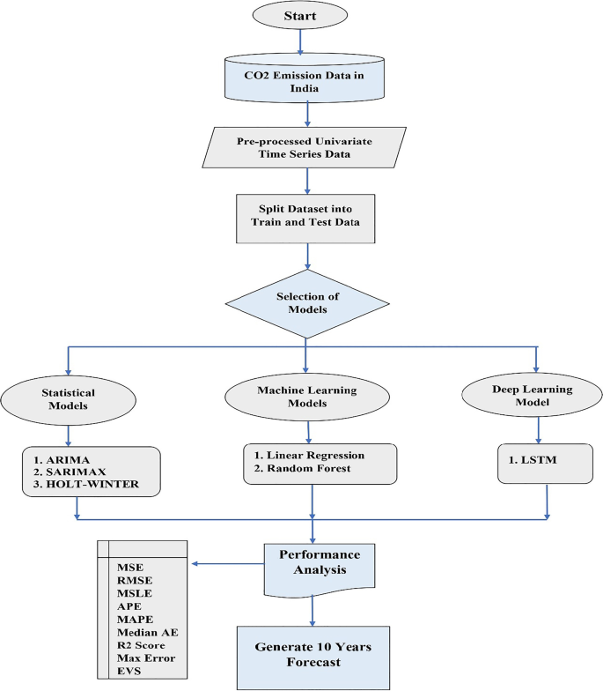
Proposed framework for CO₂ emission forecasting
Full size image
This framework initially pre-processed the dataset collected from CAIT data source. It contains 40 years of data starting from 1980 to 2019. In pre-processing, we have filled the missing values for the smooth functioning of the applied models.
We have split the pre-processed data into two parts; training and testing and then after that, we selected the six models that are from a statistical, machine learning and deep learning models to forecast the CO₂ emissions. The reason for selecting these modes is that these are suggested models for time series forecasting in various fields like business, economics, environmental science, and in science and technology.
After model selection, we trained the model by fitting the training data and then applied the trained models over test data to observe the performance. Furthermore, we have used nine performance metrics to analyse the effectiveness of the applied models. Before applying the models, the performance of the models on test data shows the efficacy; and accordingly, it is used to forecast the CO₂ emission for the next ten (10) years until 2030.

Performance metrics
In this section, we have discussed the performance metrics used to determine the effectiveness of the models. These models are used to analyze CO₂ emission, and forecasting, which is a kind of regression problem. There are many evaluation metrics; we have used nine to evaluate the models’ effectiveness. Before using all these metrics, we must know about the residual error, i.e. (y−y^)(�−�^). Here, y and y^�^ indicate the actual and predicted values. The performance metrics used to evaluate the models are as follows.

Mean squared error
In mean squared error (MSE), first, calculate the squares of the residual error as defined above for each data point and then calculate the average of that(Ağbulut et al. 2021a; R. Kumar et al. 2020)
MSE=1n∑i=1n(yi−yˆi)2���=1n∑i=1n(yi−y^i)2
(2)
where y_{i} and y^i�^� indicate the actual and predicted values, respectively. n indicates the number of data points. The study of (Bakay and Ağbulut 2021) suggests that MSE values can vary from 0 to ∞ where smaller values are preferable.

Root mean squared error
It is the same as MSE, the only addition is a square root sign (R. Kumar et al. 2020) The formula for mean absolute error is represented in Eq. (3).
RMSE=∑i=1n(yˆi−yi)2n−−−−−−−−−−−⎷RMSE=∑i=1n(y^i−yi)2n
(3)
Root mean squared error (RMSE) takes the values from 0 to ∞, and the smaller RMSE values are desirable (Bakay and Ağbulut 2021).

Mean squared log error
In mean squared log error (MSLE), the residual error is calculated with the logarithm of the original and predicated values. It is an extension on mean squared error (MSE), mainly used when predictions have large deviations. The formula for mean absolute log error is represented in Eq. (4).
MSLE=1n∑i=1n(log(yi)−log(yˆi))2MSLE=1n∑i=1n(log⁡(yi)−log⁡(y^i))2
(4)
Also, this metric does not deal with negative values, so if there is any negative error value for any data point in the dataset, then this metric will not be applicable.

Mean absolute error
Mean absolute error (MAE) is the sum of the absolute residual error. That means it does not matter about negative or positive (R. Kumar et al. 2020). The formula for mean absolute error is indicated in Eq. (5).
MAE=∑ni=1|yˆi−yi|nMAE=∑i=1n|y^i−yi|n
(5)

Mean absolute percentage error
Mean absolute percentage error (MAPE) is defined with the addition of percentage to MAE (R. Kumar et al. 2020). For a good model, a smaller MAPE value is desirable. The formula for mean absolute percentage error is shown in Eq. (6).
MAPE=100%n∑i=1n∣∣∣yi−yˆiyi∣∣∣MAPE=100%n∑i=1n|yi−y^iyi|
(6)
If the MAPE value < 10%, then the prediction will be classified as the “high prediction accuracy.”
If the MAPE value ranges between 10 and 20%, the prediction will be classified as “good prediction accuracy.”
If the MAPE value ranges between 20 and to 50%, predictions will be classified as “reasonable predication accuracy.”
And if MAPE value > 50%, then predication will be classified as “inaccurate prediction accuracy”(Ağbulut et al. 2021b).

Median absolute error
The median absolute error is robust to outliers, making it interesting and capable enough to deal with the impacts of outliers on whole prediction (Yin and Xie 2021). The formula for median absolute error is represented by
MedAE(y,yˆ)=median(|y1−yˆ1|,………|yn−yˆn|)MedAE(y,y^)=median(|y1−y^1|,………|yn−y^n|)
(7)
The median absolute error (MedAE) is a robust measure of the variability of a univariate sample of quantitative data. Its value could be anything between 0 and infinity. Therefore, the lesser the value, the higher the accuracy of the model will be.

Max error
The max error metric calculates the maximum residual error. The formula for max error is shown in Eq. (8).
Maxerror=Max∣yi−yiˆ∣Maxerror=Max∣yi−yi^∣
(8)

R ² score error
The formula for R² square error also has it significance in measuring the effectiveness of the models (Shaikh et al. 2021; Ağbulut et al. 2020); it is defined as shown in Eq. (9).
R2=1−∑ni=1(yˆi−yi)2∑ni=1(yi−y¯¯¯i)2R2=1−∑i=1n(y^i−yi)2∑i=1n(yi−y¯i)2
(9)
R ² score error, also known as the determination coefficient, ranges from 0 to 1. It gives a clue on how well the trends of the model results is able to track the trends of actual data (Ağbulut et al. 2021b). If the value is closer to 1, the model will be considered more accurate, so the more significant values is desirable.

Explained variance score error
The explained variance score error is calculated to measure the proportion of the variability of the predictions of the applied machine learning models. Variance measures how far observed values differ from the average of predicted values, i.e., their difference from the predicted value mean (Dos Santos et al. 2021). It can be seen as indicated in Eq. (10).
EVS(y,yˆ)=1−var(y−yˆ)var(y)EVS(y,y^)=1−var⁡(y−y^)var⁡(y)
(10)
It is a fundamental concept for the R² score error; also, that model will be the best fit with the higher EVS value. It also ranges from 0 to 1(Good and Fletcher 1981).

Performance analysis
The performance of the proposed framework is analyzed by writing a program in a python 3.6 programming environment. We have also used Keras and Tensor flow libraries to implement the machine learning and deep learning-based models. The applied models for predictions are analyzed as follows.

Experiment: performance observation of the models
We have applied the models on CO₂ emission dataset, after splitting the dataset into training and test samples. Trained models are applied to the test dataset to observe the models’ performances. Table 2 shows the performances of the applied models; here, in Table 2, we can see that the MSLE value for the ARIMA model is not available because it cannot be applied to a negative error value.
Table 2: The error rate of models on given CO₂ emission dataset
Full size table
Furthermore, we have also plotted the bar graph of the applied models to observe the relative performances, as shown in Fig. 3. Observations from Fig. 3(a), 3(b), and 3(f), it can be seen that LSTM, SARIMAX, and Holt-Winters models have the lowest MSE, RMSE, and MAE values in comparison to other models.
Fig. 3
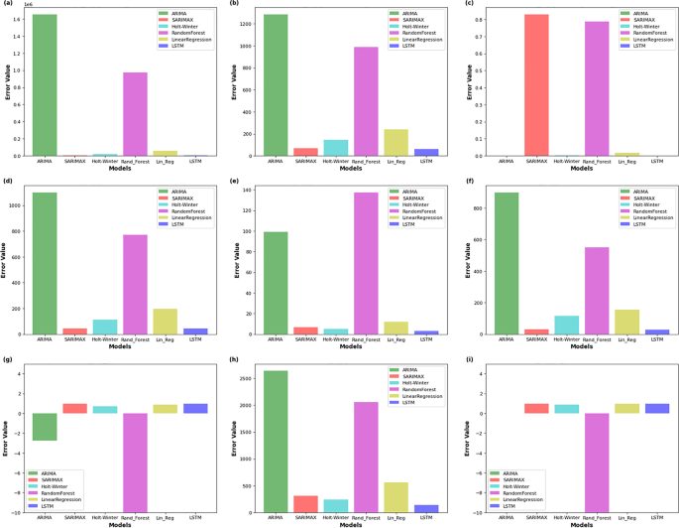
Comparative error plot w.r.t. models
Full size image
Similarly, they have lower MAPE and max error values in decreasing order of w.r.t. models SARIMAX, Hot-Winter, and LSTM.
Observations from Fig. 3(d), SARIMAX and LSTM have the lowest MAE values. Similarly, when we look at the R² score error and EVS error in Fig. 3(g) and (i), the models Holt-Winters, linear regression, and SARIMAX have the least error value in increasing order. Last, we have the remaining MSLE referring to Fig. 3(c) LSTM, Holt-Winters, and linear regression with the least error value in ascending order. Also, ARIMA is not participating in it negative predictions, which MSLE cannot handle.
Overall observation from Fig. 3 shows that LSTM, SARIMAX, and Hot-Winter are better performing models for time series forecasting data.
These three models can be applied for effective CO₂ emission predictions. When looking at all nine performance metric values, we can say that LSTM is one of the best-performing models.

Experiment: 10 years forecasting of CO₂ emissions
In this section of the experiment, we have applied the models to forecast the CO₂ emissions for the next 10 years i.e. from 2020 to 2030. Table 3 shows the summarized results of the forecasted values of the models.
Table 3 10 years forecast of all model
Full size table
In this section, we have plotted the graph for the actual CO₂ emissions for the entire dataset and predicted the values from 2010 to 2019 by applying the models as mentioned earlier. Furthermore, we have forecasted the values from 2020 to 2030.

ARIMA’s forecasting
From Fig. 4, it can be observed that ARIMA’s predicted values are too far from the actual CO₂ emissions. Our experiment tested the dataset we have for prediction with an increasing trend only, which means non-stationay in nature, also tested by ADF test (Ajewole et al. 2020). ARIMA model work on stationary data, so we have to convert data into stationary one. In the conversion process, we shifted the data and differentiated it, which caused the loss of information. This reason makes the model to give an inaccurate result. Here, in our experiment, we used Arima (1,2,1) for prediction. From Table 2, it can be seen that the ARIMA model has a MAPE value of 98.969%, which is inaccurate. Therefore, we can conclude that forecasting for 2020 to 2030 will not be appropriate.
Fig. 4
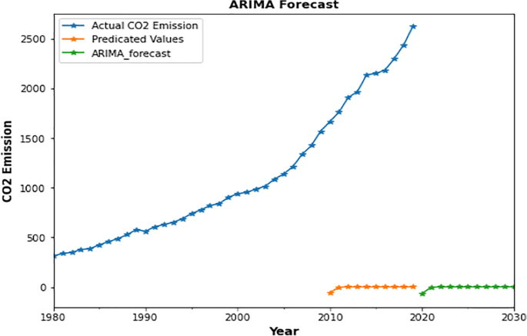
ARIMA forecasting vs. actual CO₂ emission
Full size image

SARIMAX forecasting
SARIMAX forecasting is almost in the same pattern as the actual CO₂ emission can be seen from Fig. 5. It can be used as one of the appropriate models for forecasting the CO₂ emission. This better performance because it can capture the information from its seasonality. It also takes care of exogenous factors in model training and makes a good prediction.
Fig. 5
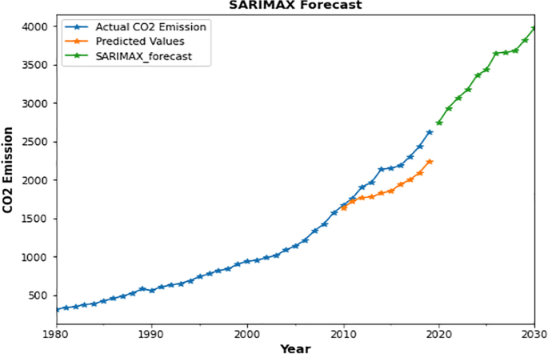
SARIMAX forecasting vs. actual CO₂ emission
Full size image
Also, we can see from Table 2, the MAPE value is the third smallest value at 6.554%, which clearly makes SARIMAX a better model.

Linear regression forecasting
Figure 6 shows that CO₂ predicted values by linear regression and actual emission, which is quite similar. We know that the linear regression model determines a mathematical equation under the black box while training the data with train data, so the linear relation assumes the output used as a predictor in the testing phase and then in forecasting.
Fig. 6
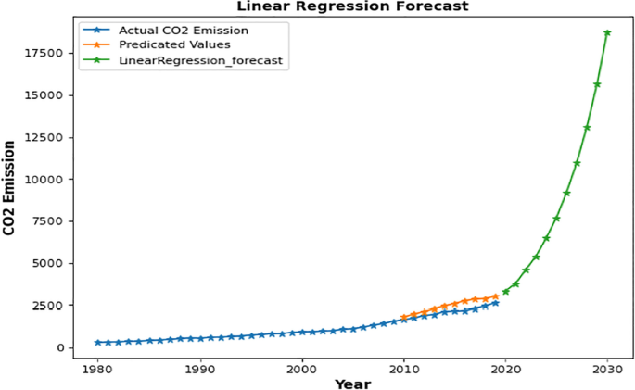
Linear regression forecasting vs. actual CO₂ emissions
Full size image
But because of performance metric values of linear regression on test data, it is hard to rely on forecasting. As we can see from Table 2, the MAPE value is the fourth smallest value with 12.023%, which clearly makes the Linear model a good model, but not the best.

Random forest forecasting (RF)
A random forest is an ensemble machine learning technique that constructs multiple trees while training data and gives class labels for classification problems or mean/average prediction for regression. It can also be used in both univariate and multivariate time series forecasts by manually creating lag and seasonal component variables. According to the nature of data, different algorithms react differently, so we have to try it over our dataset. We tried our dataset into a random forest model in our work, which did not perform well.
Figure 7 shows the CO₂ predicted values, which is quite different from actual emissions. Also, the MAPE value is also maximum with 137.239%, which gives the worst prediction. Therefore, we can conclude that the random forest model is not appropriate for CO₂ emission forecasting.
Fig. 7
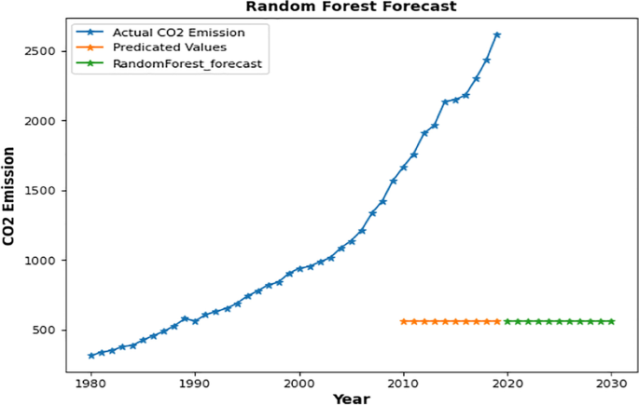
Random forest forecasting vs actual CO₂ emission
Full size image

Holt-Winters model forecasting
We can see from Fig. 8 that Holt-Winters-predicted values are quite similar to actual CO₂ emissions. This model can also be considered one of the effective forecasting models if we compromise a few performances metric values. The Holt-Winters model is used for exponential smoothing using “additive” or “multiplicative” models with increasing or decreasing trends and seasonality to make short-term forecasts. In our work, we have a multiplicative variant of the model, which took care of all three aspects of time series data i.e average, trend, and seasonality, and gave satisfying results. Also, from Table 2, the MAPE value is the second smallest value at 5.043%, which clearly makes Holt-Winters a suitable prediction model.
Fig. 8
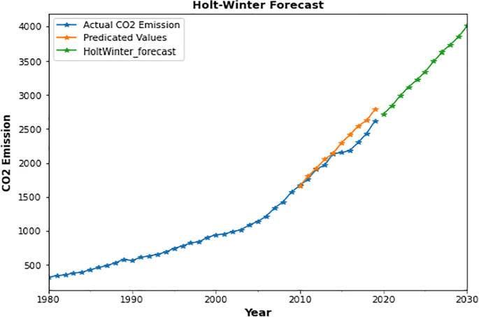
Holt-Winters forecasting vs. actual CO₂ emissions
Full size image

LSTM model forecasting
Figure 9 shows the LSTM behavior for prediction and forecasting of the CO₂ emissions. The LSTM is a model that uses the recurrent neural network concept but has a short memory element in the form of a series of logic gates to train the model and make the predictions. This model also destroys the problem of exploding and vanishing gradient. This is the reason this model is performing well.
Fig. 9
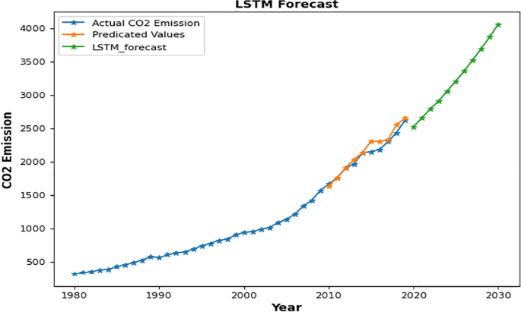
LSTM forecasting vs. actual CO₂ emissions
Full size image
Observations from Fig. 9 show that when we compare the actual CO₂ emissions and predicted value (as indicated from 2010 to 2020) are almost identical. We have already analysed from Fig. 3 that LSTM is the best performing model in terms of performance metric values. As we can see from Table 2, the LSTM model has the lowest value of 3676.646 and 60.635 for MSE and RMSE, respectively, and for these metrics, smaller values are desirable. Hence, this is the best forecasting model. MSLE metric values for the LSTM model are also lowest with 0.001 than in other models.
The MAE value for the LSTM model is 45.524, the second smallest among all models, which seems very appropriate for forecasting. MAPE is again the smallest value with 3.101%, which makes LSTM an excellent model. MedAE and MaxError have the lowest value with 28.898 and 135.933, respectively, and obviously, the LSTM outperformed here. The last R² score error is 0.990, most desirable, and EVS error is also 0.990, tied up with the SARIMAX model. Therefore, we can conclude that LSTM is the best-performing model to forecast the CO₂ emission.

Statistical analysis
In this section, we have applied the Friedman test (García et al. 2010) to verify the best-performing model statistically.
Observations from Fig. 10 show that LSTM is the best performing model with the highest rank value of 4.72. Therefore, the LSTM model can be used to forecast the CO₂ emission effectively.
Fig. 10
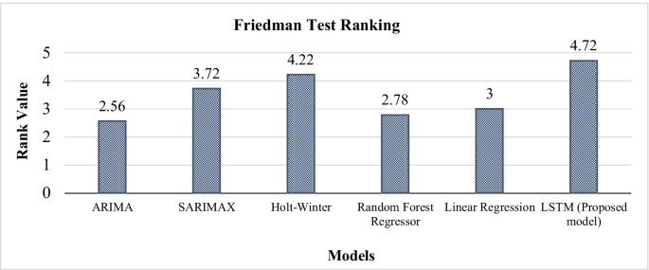
Comparative rank of the models
Full size image

Comparative forecasting
In this section, we have shown the comparative forecasting values for CO₂ emissions from 2020 to 2030.
Observations from Fig. 11 show that LSTM, SARIMAX, and Holt-Winters are appropriate forecasting models. Furthermore, when we look at the performance metric values, then the LSTM is the best performing model for forecasting the CO₂ emissions.
Fig. 11
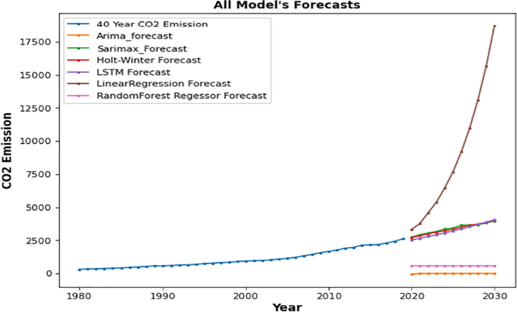
Comparative forecasting of CO₂ emissions from the year 2020 to 2030
Full size image

A comparative study with recent work
In this section, we have analyzed the comparative performance of the proposed model with the recent works (MK 2020) and (Hewamalage et al. 2021). The work by (MK 2020) proposed the ANN model as a best forecasting model for CO₂ emission along with economic growth. Similarly, (Hewamalage et al. 2021) proposed that RNN (Recurrent Neural Network) as the best forecasting model over the competitive M4 dataset.
Now we have applied both the ANN and RNN model to our univariate CO₂ emission dataset, it is observed that ANN is performing better than RNN but both are not better than our proposed model LSTM.
From Fig. 12, it can be observed that the proposed LSTM model is the best-performing model for univariate CO₂ emission forecasting w.r.t. the performance metrics RMSE, MAE, MAPE, MedianAE, EVS, and MSLE. Therefore, we can conclude that the proposed LSTM model is one the best model for CO₂ emission forecasting.
Fig. 12
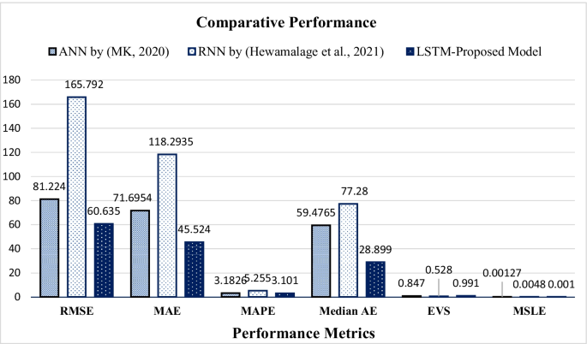
Comparative analysis of the proposed model
Full size image

Conclusion and future research directions
The accurate prediction of CO₂ emission in India in the coming decades is crucial for people’s lives and the government. As per the available data, India is in the second position in the largest CO₂ emitting countries. The contribution of our work is to control the CO₂ emission to save human lives. In this work, we have applied the statistical, machine learning, and deep learning-based time series model to observe the CO₂ emission pattern. The performance of these models is evaluated based on nine appropriate performance metrics to choose a suitable one for future forecasting.
Findings indicate that out of applied models LSTM, SARIMAX, and Holt-Winters are better performing models for effective CO₂ emission prediction. To analyze the performance of the applied models, we have used the 40 years of CO₂ emission data. The result performance metrics-based observations conclude that LSTM is the best performing model with a 3.101% MAPE value, 60.635 RMSE value, and 28.898 MedAE values. Only the MAE value predicts SARIMAX as best. And EVS error value is tied between both LSTM and SARIMAX. We have also performed the Friedman test to show the statistical significance of the proposed model. In which, we have observed that LSTM has the highest Friedman ranking value 0f 4.72, indicates that it is one of the most suitable models for CO₂ emission forecasting.
Furthermore, a comparative study done with the recent works using the performance metrics RMSE, MAE, MAPE Median AE, EVS, and MSLE to conclude the suitability of the proposed model. The comparative results conclude that LSTM is the most suitable model along with the lowest errors in RMSE, MAE, MAPE, Media AE, and MSLE. Therefore, the LSTM model is proposed to be the best model and is used to forecast the next 10 years (2020 to 2030) years CO₂ emissions.
According to the LSTM model, CO₂ emission will be approximately five thousand metric tons which is two times of current CO₂ emission if it will keep going at the same pace, so appropriate CO₂ emission forecasting would be fruitful for the upcoming governments to frame their policies to abide by the UN-specific reduction measures, i.e. reducing CO₂ emission by 58% by 2030. As a result, it is strongly advised that governments implement various policies, rules, norms, limits, and legislations to minimise CO₂ emissions and fossil-fuel usage in the various sectors.
- A few suggestions for policy-making could be increasing taxes on ecologically damaging uses.
- Imposing carbon taxes, cap-and-trade systems, carbon offsets, carbon caps, and eco-friendly technology standards.
- To educate people about the issues that create pollution and to raise community consciousness in society.
- Introducing free bus policies and promoting the electric vehicles would reduce the national fuel usage and the country’s carbon impact.
- India should use low carbon-emitting sources like carbon-free hydrogen and sustainable biofuels for its power supply and reduce its dependence on coal, as it is an emerging renewable energy leader.
- Voluntary approaches should be adopted as a tool to reduce industrial emissions.
This work is limited only to univariate data prediction for CO₂ emission. We have not inculcated many factors such as population growth, economic growth, advancing technology, switching to renewable energy sources, and future government actions. These are a few exogenous factors that future researchers can explore. They may find a way to deal with such deviations due to these factors so that the new models could forecast data with more accurate CO₂ emissions. After including the factors above, we can find the correlation among them, and multivariate analysis can be done for effective CO₂ emission prediction.

